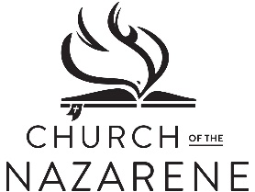
Parkside Church of the Nazarene
23600 Hilliard Blvd., Westlake, OH 44145
440-333-3998 / www.parknaz.org / dlain1058@gmail.com

January 14, 2021

Dear Church Family:

As the year 2021 has come, I find myself moving into the new year with great expectation and hope. I’m believing God has great things in store. Unfortunately, some of 2020 has followed us into the new year, most specifically the pandemic. Rather than subsiding, the pandemic is more active than ever. Therefore, the writing of this letter.

Some have been asking when we will resume meeting together again in the sanctuary. I’m writing to inform you of action taken by your church board at Tuesday’s monthly board meeting. After careful and thoughtful deliberation, it was determined that we must continue in our current format with ONLINE SERVICES ONLY. This is hard to hear, but please know that the board made the decision in a prayerful effort to do what’s best. The overarching concern is the welfare of our congregation that is composed of a large percent of people in the most vulnerable category.

It is the board’s intention to have us resume meeting as soon as possible, so we will be watching indicators (a significant drop in daily cases and deaths in our county) and activities (how quickly most of us can be vaccinated). We are fully aware that Lent and Easter are coming soon, and how we would love to be together for this important season. When the board feels that things are moving in a positive direction, we will meet again and take action.

As was stated in the November 2020 letter that announced our current status, Paul instructs us to “encourage one another and build each other up, just as in fact you are doing.” (I Thessalonians 5:11) Although we’ll not be together physically, we must be together! Make a phone call. Send an email. Send an encouraging card to someone God brings to your mind. We can be together in heart and mind! Let’s replace loss with gain as we move through this together.

Finally, let us PRAY, PRAY, PRAY!!

Pastor Don Lain

